

W6 PRACTICE
FORMS & INPUTS

 What are the objectives for this session?
- Learn and use various HTML form input types
  - text, checkbox, radio, dropdown, text area, range, color, selector etc.

- Apply basic CSS styles to enhance the appearance of form inputs
  - borders, colors, padding, margins etc.

- Use: :focus :hover : checked :checked :indeterminate CSS pseudo-classes

 How to start?
✔ Download the start code from the LMS
✔ Open the folder in VS Code

 How to submit your work?
✔ Push your final code on your GitHub repository
✔ Then attach the GitHub path to the MS Team assignment and turn it in

 Are you lost?
You can read the following documentation to be ready for this practice:
- Guide - WC3 School
- The Form element
- HTML Forms



PART 1: LEARN – 45 MIN
- Read or watch resources on internet to learn about HTML Inputs: Guide - WC3 School
The Form element HTML Forms

- Complete the bellow table.

INPUT TYPE | USAGE | EXAMPLE
Text | defines a one-line input field for text input | <input type="text">
radio | Select one option from multiple choices | <input type="radio">
checkbox | Select MULTIPLE options | <input type="checkbox">
range | Slider input for selecting a number within a range | <input type="range">
submit | Button to submit a form | <input type="submit">
textarea | Multi-line text input | <input type="textarea">
select | Drop-down list | <input type="select">
color | Pick a color | <input type="color">
file | Upload a file | <input type="file">

- Read or watch resources on internet to learn about Inputs styling: https://www.w3schools.com/css/css_form.asp

- Complete those mini challenges by writing your code on bellow table:

MINI CHALLENGES | YOUR CODE (HTML + CSS)
Highlight the input field when it is focused | <!DOCTYPE html>  <html>  <head>  <style>  input {  padding: 8px;  border: 2px solid #ccc;  border-radius: 4px;  transition: 0.3s;  }  input:focus {  border-color: #007bff;  background-color: #e8f0ff;  }  </style>  </head>  <body>  <input type="text" placeholder="Click here to focus">  </body>  </html>
Change the button background color on hover | <!DOCTYPE html>  <html>  <head>  <style>  input {  padding: 8px;  border: 2px solid ;  border-radius: 4px;  transition: 0.3s;  }  input:hover {  border-color: #007bff;  background-color: #e8f0ff;  }  </style>  </head>  <body>  <input type="submit" placeholder="Submit">  </body>  </html>
Create a search bar with rounded corners and a shadow effect | <!DOCTYPE html>  <html>  <head>  <style>  .search-bar {  width: 250px;  padding: 10px 15px;  border-radius: 25px;  border: 1px solid #ccc;  box-shadow: 0 0 8px rgba(0,0,0,0.15);  outline: none;  transition: 0.3s;  }  .search-bar:focus {  box-shadow: 0 0 10px rgba(0,122,255,0.6);  border-color: #007aff;  }  </style  </head>  <body>  <input type="text" class="search-bar" placeholder="Search...">  </body>  </html>
Display a different style when the checkbox is checked | <!DOCTYPE html>  <html>  <head>  <style>  .custom-check {  width: 18px;  height: 18px;  accent-color: #007bff;  cursor: pointer;  }  .custom-check:checked {  transform: scale(1.2);  transition: 0.2s;  }  </style>  </head>  <body>  <input type="checkbox" class="custom-check">  </body>  </html>
HARD!  Style a checkbox to have three states: unchecked, checked, and indeterminate.  TIP  Use CSS pseudo-classes (:checked and :indeterminate)  for styling. | <!DOCTYPE html>  <html>  <head>  <style>  .box {  width: 20px;  height: 20px;  appearance: none;  border: 2px solid #555;  cursor: pointer;  position: relative;  }  .box {  background: #fff;  }  .box:checked {  background: #4caf50;  border-color: #4caf50;  }  .box:checked::after {  content: "✓";  color: #fff;  position: absolute;  left: 3px;  top: -2px;  font-size: 15px;  }  .box:indeterminate {  background: #ffcc00;  border-color: #ffcc00;  }  .box:indeterminate::after {  content: "";  width: 12px;  height: 3px;  background: #333;  position: absolute;  top: 50%;  left: 50%;  transform: translate(-50%, -50%);  }  </style>  head>  <body>  <input type="checkbox" class="box" indeterminate>  </body>  </html>

- Some groups will be selected to present and explain their work to the whole class

PART 2: PRACTICE – 45 MIN
You need to reproduce – as close as possible - the bellow table. Before coding, identify the following point:
- Elements: What are the different inputs you will need?

- Layout: what kind of CSS layout do you need? Why?

- Input styling: What are the styles you need to apply on your inputs?
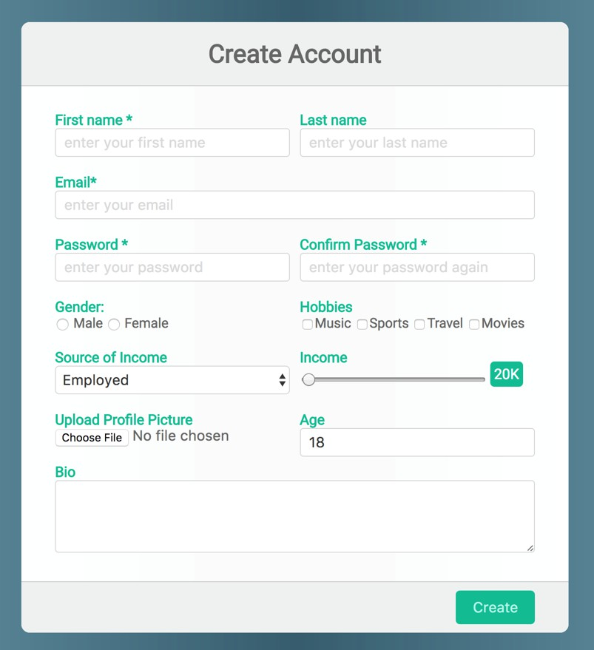
Be as close as possible to this mockup

